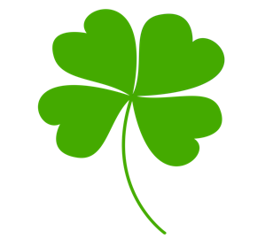
This Photo by Unknown Author is licensed under CC BY-NC
This Photo by Unknown Author is licensed under CC BY-NC
This Photo by Unknown Author is licensed under CC BY-NC
This Photo by Unknown Author is licensed under CC BY-NC

This Week in Kindergarten
March 4-8, 2023

REMINDERS

The Kindergarten Mass is this Thursday, March 7 at 8:30 am

No School Monday, March 1 1

No BUSSING Tuesday, March 12
READING:
Stories: Duck and Goose, Curious George’s Dinosaur Discovery
High Frequency words: review
Grammar:
Verbs: past, present, and future
Synonyms

MATH:
Addition: number lines, creating models to solve addition within 10

SOCIAL STUDIES:
Voting

SCIENCE:
Plants

Religion:
Lent

