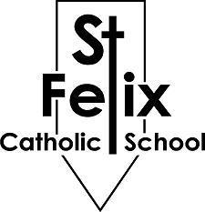
ST. FELIX CATHOLIC SCHOOL
GOLF TOURNAMENT OPPORTUNITIES

PLEASE RETURN BY TUESDAY, APRIL 28, 2026

______ Yes, I would like to be a Hole Sponsor. Enclosed is my $150 check made out
to: St. Felix Golf Fundraiser
Please list my Business/Name as:

______ Yes, I plan to promote my business at my sponsored hole with an activity
My “On-Course” Activity includes:

______ Yes, I would like to donate a prize/giveaway.
My donation will be:

______ I will drop my donation off at St. Felix Catholic School by April 28th

______ Please pick up my donation at my place of business.

I will have it ready by:

______ Yes, please sign me up for Golf – Attached is my completed sign up form.

______ Yes, I would like to purchase ______ Dinner Only tickets. Enclosed is $25 for each ticket.

______ Yes, I would like to purchase ______ Balls for the Ball Drop. Enclosed is $5 for each ball.

______ No, I am not able to participate this year, but please contact me next year.

Name:

Please make checks payable to St. Felix Golf Fundraiser
PLEASE RETURN TO ST. FELIX CATHOLIC SCHOOL BY APRIL 28TH

or Mail to:

St. Felix Golf Fundraiser
St. Felix Catholic School
130 3rd Street East
Wabasha, MN 55981

